# Appendix B: Histological Investigations into the Effects of *p*CO2 and a second stressor in Pacific Oysters

Histology analysis done by Jessica Blanchette

## Introduction

Intertidal species have evolved in a notoriously variable and stressful environment in which they frequently encounter conditions that are near the limit of their range of physiological function (Somero?). Climate change may push intertidal species beyond this range to the point of physiological damage. Many processes that are part of the response to average fluctuations in the intertidal could be affected in the physiological response to future climate scenarios. Metaplasia of digestive tubules is a common occurrence during tidal emersion as well as a general response to environmental stressors. Cycles of metaplasia of the digestive diverticula can also fluctuate seasonally (Couch 1985; Weis et al. 1995). Increased metaplasia has been associated with lesions in *Mytilus edulis* (Lowe and Moore 1979), *Crassostrea rhizophorae* die-offs (Nascimento et al. 1986), *Crassostrea virginica* exposure to environmental pollutants (Weis et al. 1995), and starvation in *C. virginica* (Winstead 1995).

This study investigates future ocean pH (i.e. ocean acidification) effects on digestive tubule metaplasia in the Pacific oyster, *Crassostrea gigas*. Our hypothesis is that elevated *p*CO2/decreased pH will increase the physiological stress experienced by the oysters and thus increase metaplasia.

Oysters were exposed to one of three *p*CO2 levels - 400 μatm (control), 1000 μatm, or 2800 μatm - for one month. Subsequently, a subset of oysters from each *p*CO2 treatment was subjected to mechanical stress to investigate the effects of ocean acidification on the oyster's stress response at the histological level.

## Materials and Methods

Experimental set-up and oyster sampling were accomplished as described in Chapter 3 (see page XX). Oysters from three of the *p*CO2 treatments (400, 1000, and 2800 μatm) were analyzed for histological differences due to *p*CO2 and mechanical stress. A transverse section was taken from each oyster to include tissues from digestive gland, gill, and mantle. Sample sizes were as follows: 9 oysters for 400 μatm, 8 for 400 μatm + mechanical stress, 8 for 1000 μatm, 8 for 1000 μatm + mechanical stress, 8 for 2800 μatm, and 5 for 2800 μatm + mechanical stress.

Each tissue cross-section was placed in a histology cassette and immediately transferred to Invertebrate Davidson's fixative (Shaw & Battle 1957). After 24 hours, cassettes were transferred to 70% ethanol for storage. Slides were prepared by the Diagnostic Pathology Medicinal Group (Sacramento, CA) and were stained with Ehrlich's haematoxylin and eosin. Digestive tubules were examined for signs of metaplasia. Tubules with open and round lumen (contrasted with a 3- or 4-point star-like shape) were considered to have undergone cuboidal metaplasia (Fig. AppB.1).

All analyses were performed in R (R Core Team 2013). ANOVA was performed with *p*CO2 and mechanical stress as fixed factors.

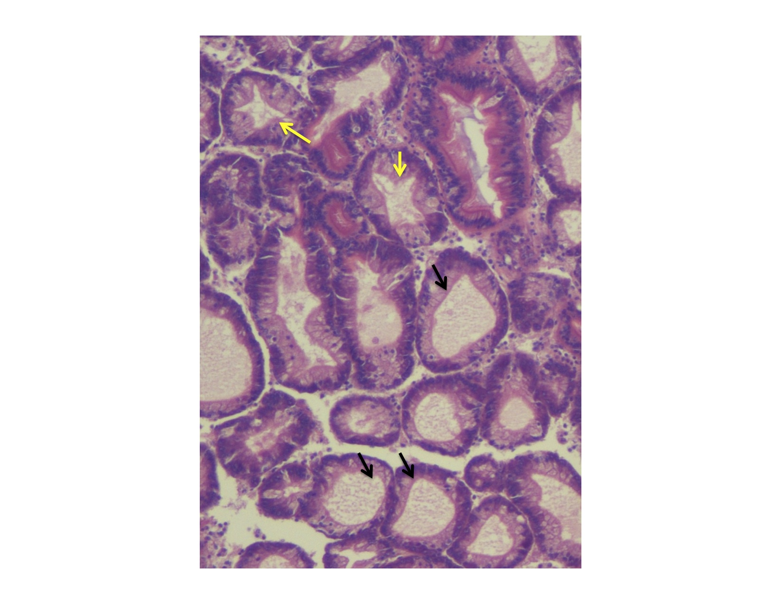

Figure Appendix B.1. Normal digestive tubules (yellow arrows) and tubules undergoing metaplasia (black arrows).

## Results

Elevated *p*CO2 had no effect on proportion of digestive tubules undergoing metaplasia (Fig. AppB.2, F = 0.0562, p = 0.9455). Across *p*CO2 treatments, mechanical stress resulted in fewer tubules with cuboidal metaplasia (Fig. AppB.2, F = 4.7870, p = 0.0323).



Figure Appendix B.2. Proportion of digestive tubules exhibiting cuboidal metaplasia. Means are plotted with 95% confidence intervals for each mechanically stressed (red) and non-mechanically stressed (blue) oysters across the three *p*CO2 treatments. Mechanical stress caused a significant decrease in metaplasia in all *p*CO2 treatments.

## Discussion

One month exposure to elevated *p*CO2 did not affect digestive tubule metaplasia in *Crassostrea gigas*, however mechanical stimulation caused a decrease in the proportion of tubules undergoing metaplasia across all *p*CO2 levels. Metaplasia is when digestive tubule cell type changes from columnar to cuboidal and seems to be naturally affected by decreased access to food either during the tidal cycle (CITE) or during starvation (Winstead 1995). Some environmental stressors also instigate digestive tubule metaplasia, but this could be an indirect effect of decreased access to food. For example, lesions proximal to digestive tubules are associated with tubule metaplasia (Lowe and Moore 1979), which may be because the lesions inhibit digestion. Additionally, exposure to high levels of pollutants causes metaplasia (Weis et al. 1995), but this could be a by-product of oyster shell closure during exposure to contaminated water, which would prevent feeding. Valve closure was observed in the clam *Corbicula fluminea* in response to elevated levels of zinc and cadmium (Doherty et al. 1987). Elevated *p*CO2 does not seem to affect access to food in *C. gigas*, as evidenced by lack of digestive tubule metaplasia as well as by its lack of effect on fatty acid profiles (see Chapter 3).

Mechanical stress consistently caused a decrease in proportion of tubules undergoing metaplasia in all *p*CO2 treatments. This finding is in contrast to previous hypotheses that metaplasia is a general stress response in bivalves (Couch 1985). The oysters that underwent mechanical stimulation may require more resources to deal with this exogenous stress and one response to this requirement may be to increase the number of digestive tubules that function in food absorption. A similar effort to mobilize resources after exposure to mechanical stress was also seen at the proteomic level (see Chapter 3 Discussion).